Kathryn Schauer, Nicholas Smythe, Joseph Scerbo

CS104 – Sprint 4

Sprint 1 code:

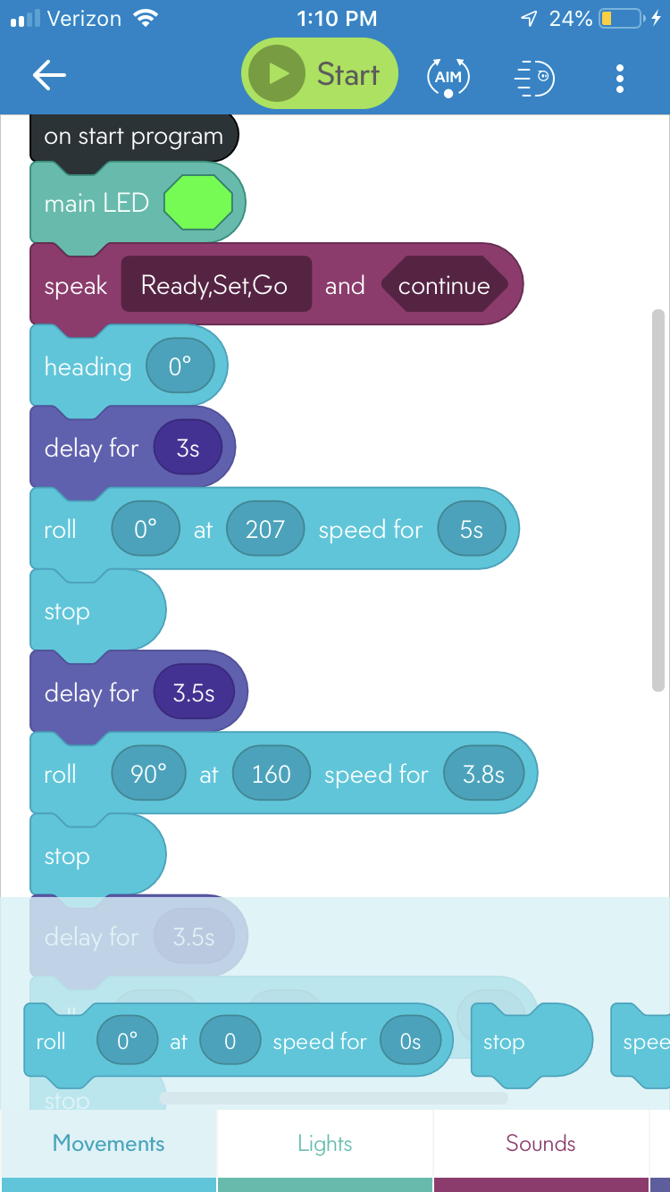

Continued

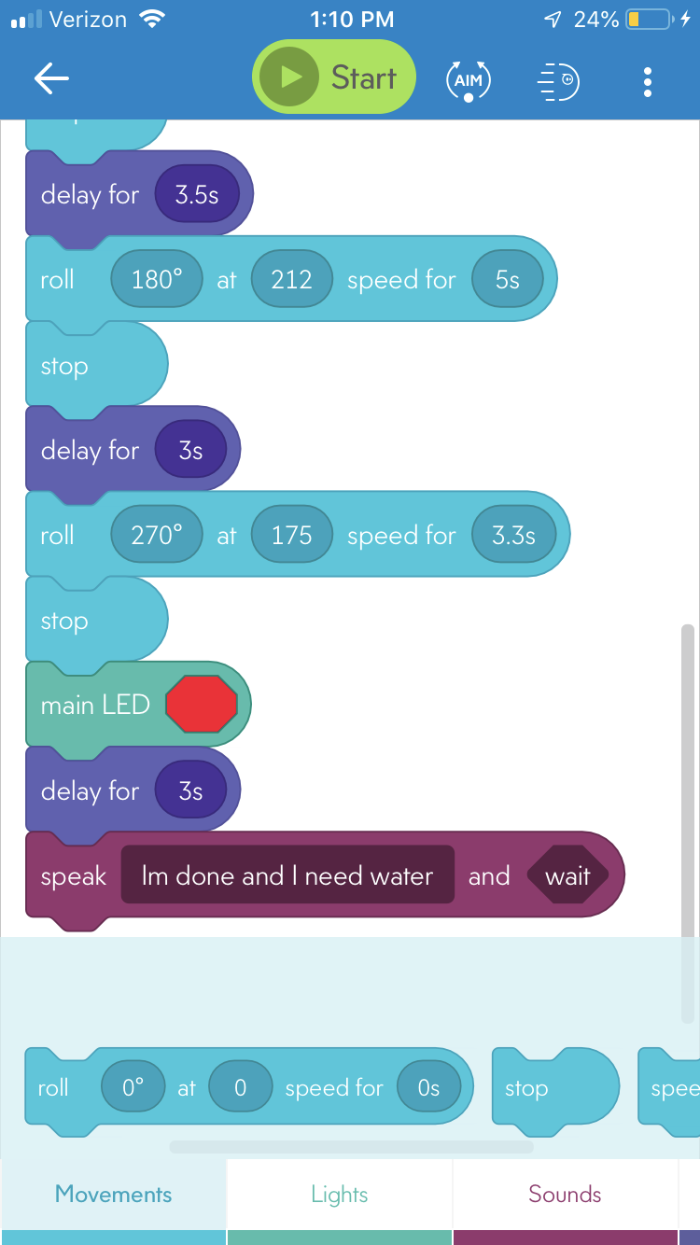

Sprint 2 code:

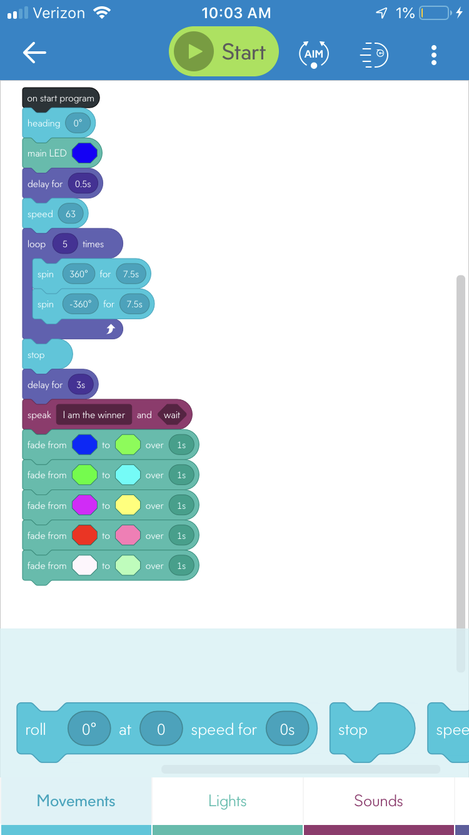

Sprint 3 code:

